2124UDSM2019

PARJANE SIDDHANT VILAS
Q1. What is Leetcode?
LeetCode is an online platform that offers a vast collection of programming challenges to help developers enhance their coding and problem-solving skills. It is particularly popular among individuals preparing for technical interviews at leading tech companies such as Google, Amazon, and Microsoft. The platform includes problems spanning various topics like data structures, algorithms, databases, and system design. Users can practice questions in different difficulty levels (easy, medium, hard) and in multiple programming languages.
LeetCode also provides features like contests, company-specific interview question sets, and a discussion forum for collaborative learning. It helps users not only build their coding skills but also gain familiarity with real-world problem-solving scenarios. Moreover, the platform allows users to submit their solutions, receive immediate feedback, and compare their approaches with others for a more in-depth learning experience.

Q2. What is the purpose of Leetcode?
The primary purpose of LeetCode is to help developers and programmers improve their coding, algorithmic thinking, and problem-solving skills. It serves as a preparation tool for technical interviews, offering a wide array of problems that simulate real-world coding challenges posed by top tech companies. By practicing on LeetCode, users can familiarize themselves with common data structures, algorithms, and optimization techniques that are crucial for succeeding in these interviews.
Additionally, LeetCode aims to create a community-driven learning environment. It provides features like mock interviews, company-specific question banks, and regular coding contests to help users gauge their progress and compete globally. Beyond interview preparation, LeetCode also helps developers refine their skills for professional growth by tackling advanced topics like system design and database management. This makes it a valuable resource for both job seekers and seasoned developers looking to stay sharp in their field.

Q3. Why Leetcode is better than any other coding platforms?
LeetCode stands out among coding platforms because of its comprehensive and diverse range of problems, user-friendly interface, and features tailored for technical interview preparation. One of its key advantages is the extensive problem set, categorized by difficulty, topic, and even specific companies. This allows users to target their practice effectively, focusing on areas they need to improve or specific companies they are preparing for. The platform supports multiple programming languages, making it accessible to developers across different technical stacks.
Another reason LeetCode excels is its strong emphasis on learning and community engagement. It provides detailed solutions, discussion forums, and the ability to compare different approaches to the same problem. The platform also offers mock interviews, coding contests, and company-specific question sets, which are incredibly useful for real-world interview preparation. Unlike some platforms that focus more on competitive programming, LeetCode bridges the gap between academic problem-solving and practical, job-oriented coding skills, making it a preferred choice for many developers.

- Two sum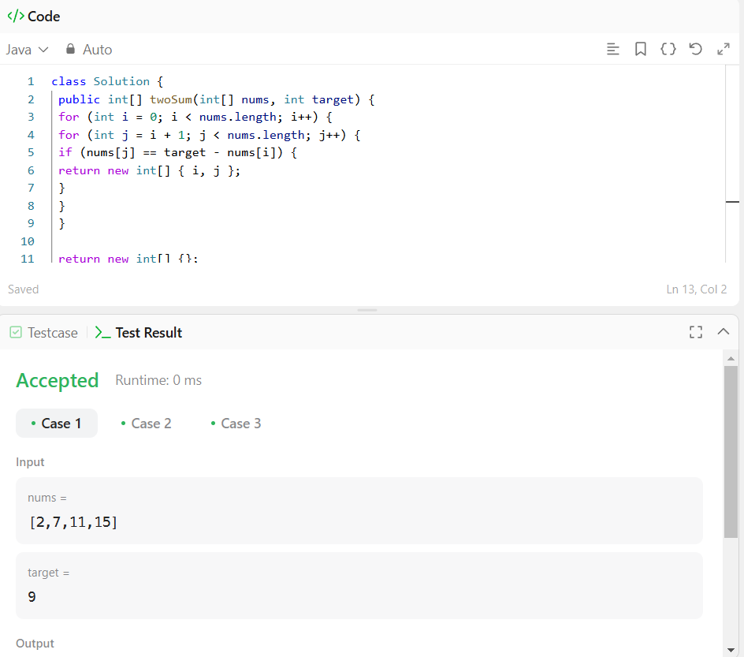

- Palindrom Number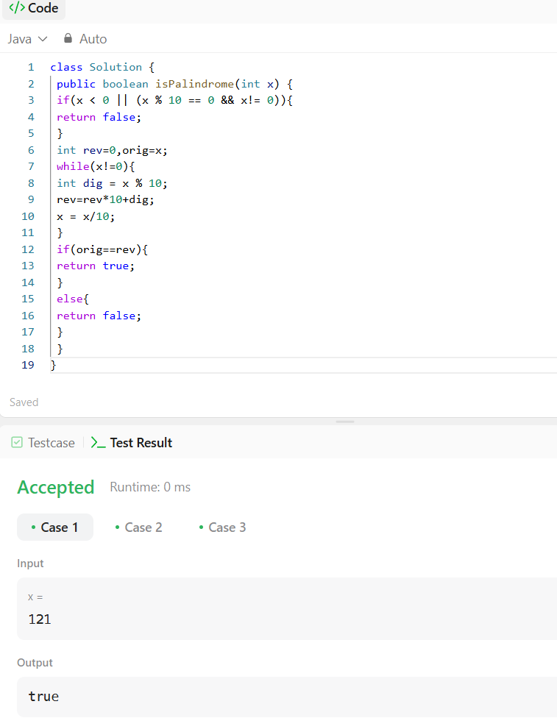

- Divide Two Integer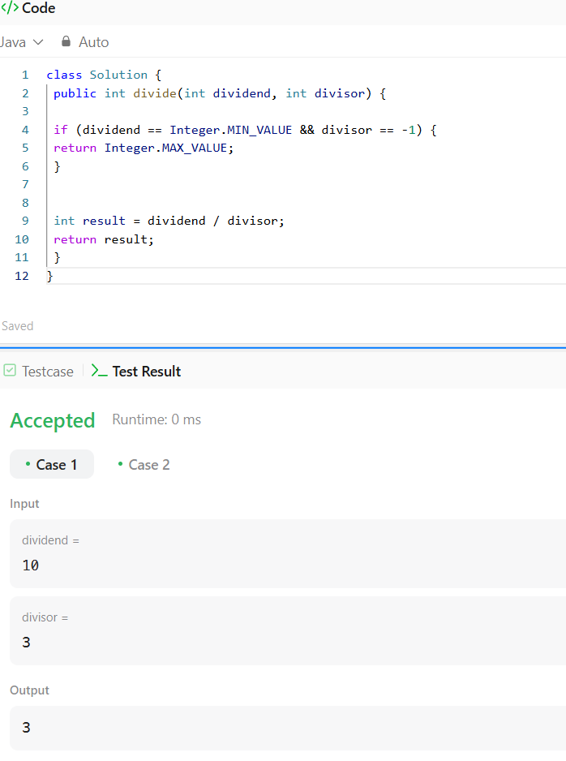

- Plus one.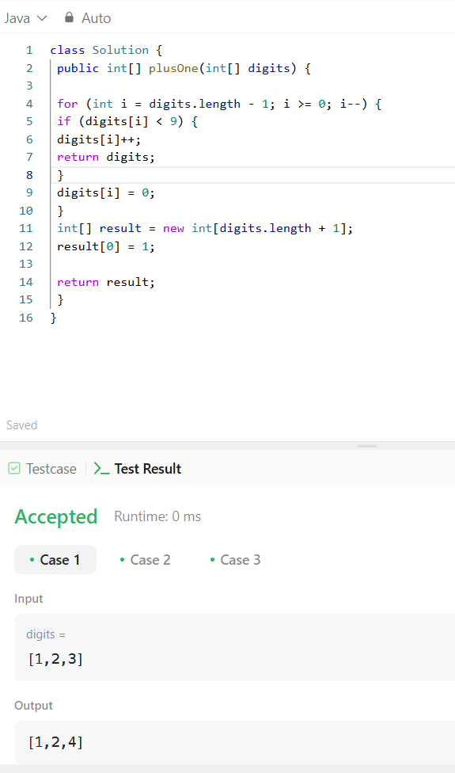

- Sqrt(x)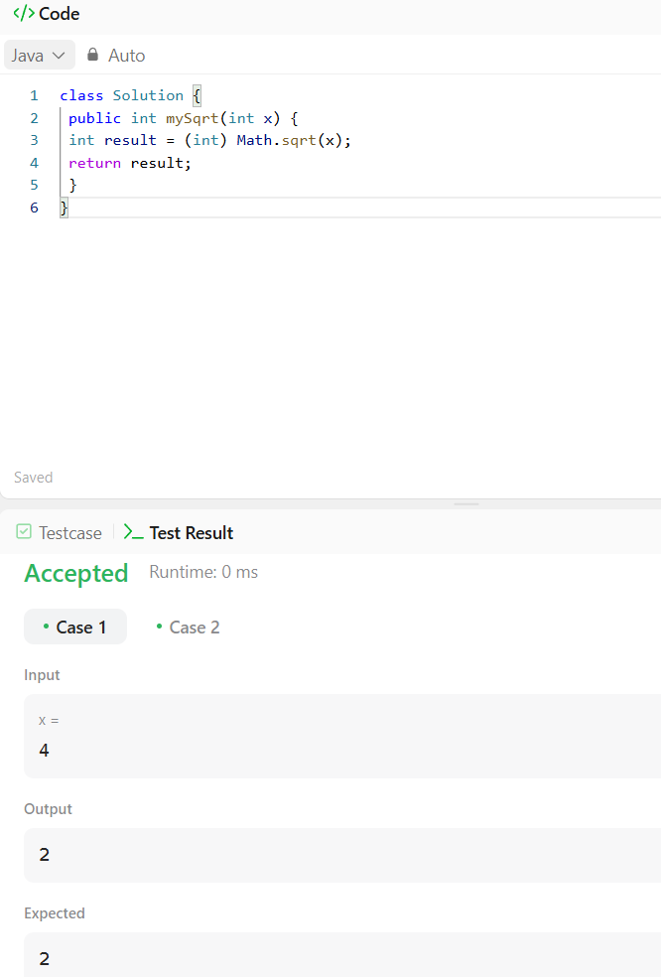

- Power of four
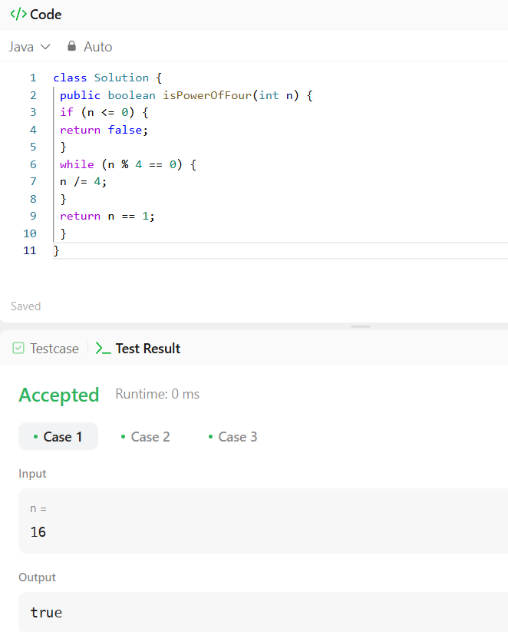

7.Add two Numbers
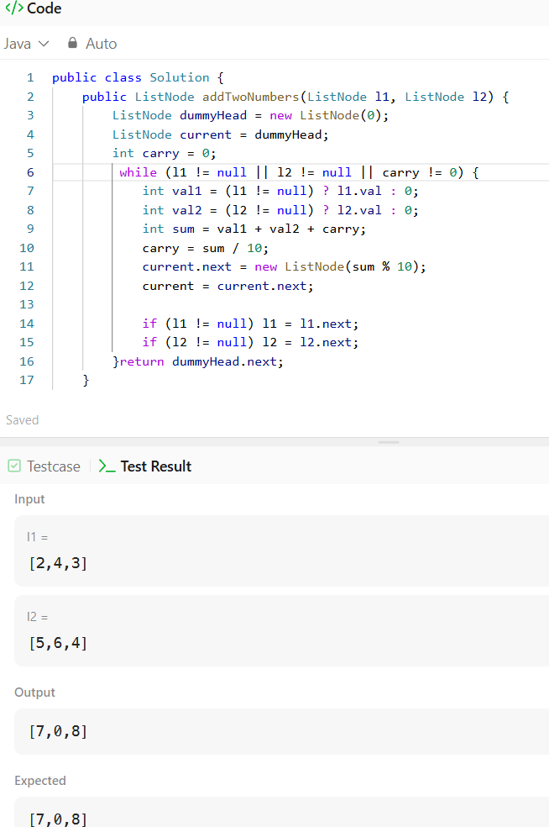

8.Triangle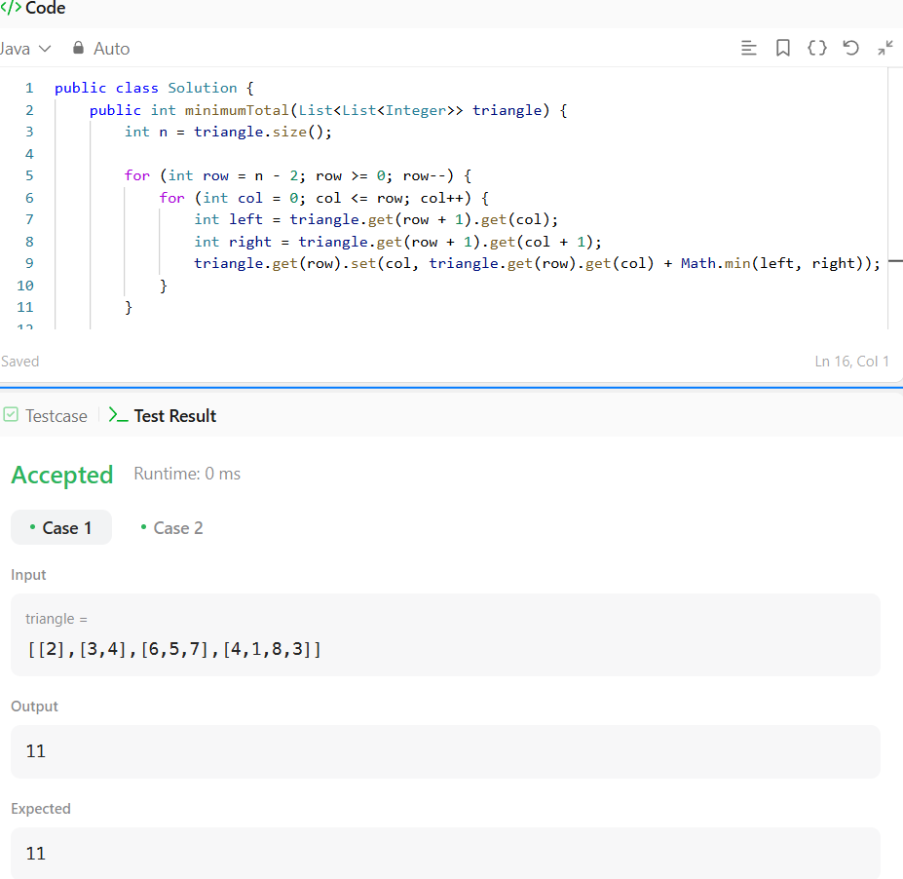

9.Largest Number
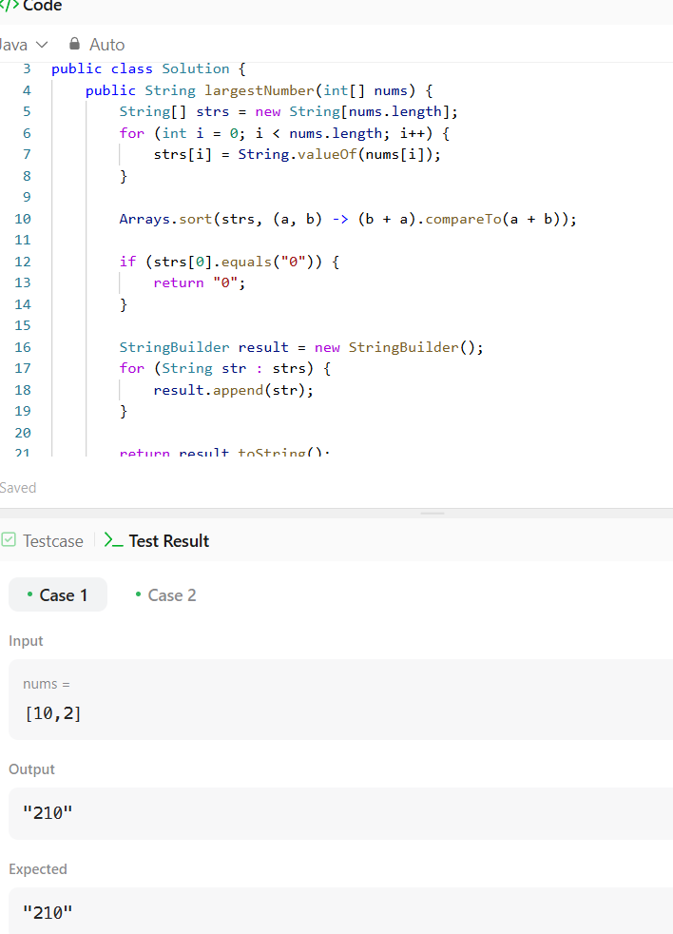

10.Fibonacci number
